**Practical – 3**

**Question 1:**

We want to develop a program that can do the following:

· Prompt the user for input of two integers, which we will call numerator and denominator. For clarity, we are only looking at integers, because this assignment is about rational numbers. A rational number can always be expressed as a quotient of two integers.

· Calculate the floating point division result (e.g. 10/4 = 2.5).

· Calculate the quotient and the remainder (e.g. 10/4 = 2 with a remainder of 2 = 2 2/4).

**Code:**

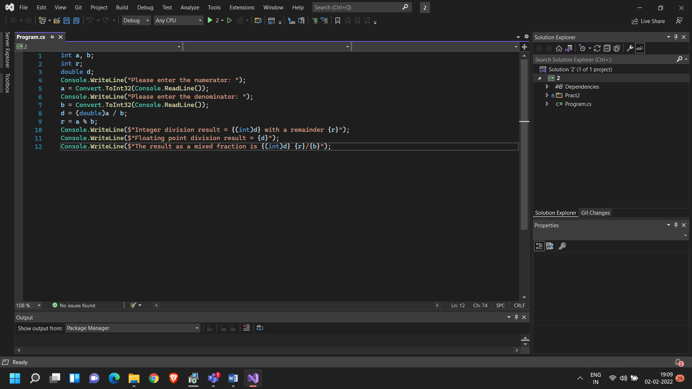

**Output:**

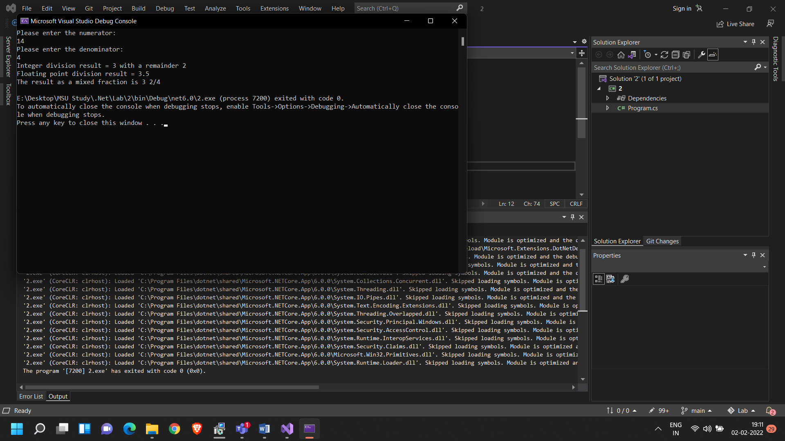

**Question 2:**

1. Read a string from the keyboard and print the length of the string, with a label.

2. Read a sentence (string) from a line of input, and print whether it represents a declarative sentence (i.e. ending in a period), interrogatory sentence (ending in a question mark), or an exclamation (ending in exclamation point) or is not a sentence (anything else).

It makes sense to only make small changes at once and build up to final code. First you might just code it to check if a sentence is declarative or not. Then remember you can test further cases with else if (...).

3. Read a whole name from a single line of user input. Do not ask for first and last names to be entered on separate lines! Assume first and last names are separated by a space (no middle name). Print last name first followed by a comma and a space, followed by the first name. For example, if the input is "Marcel Proust", the output is "Proust, Marcel".

4. Improve the previous part, so it also allows a single name without spaces, like “Socrates”, and prints the original without change. If there are two parts of the name, it should work as in the original version.

**Code:**

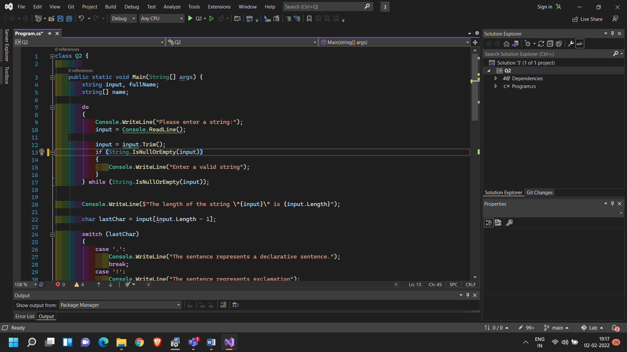

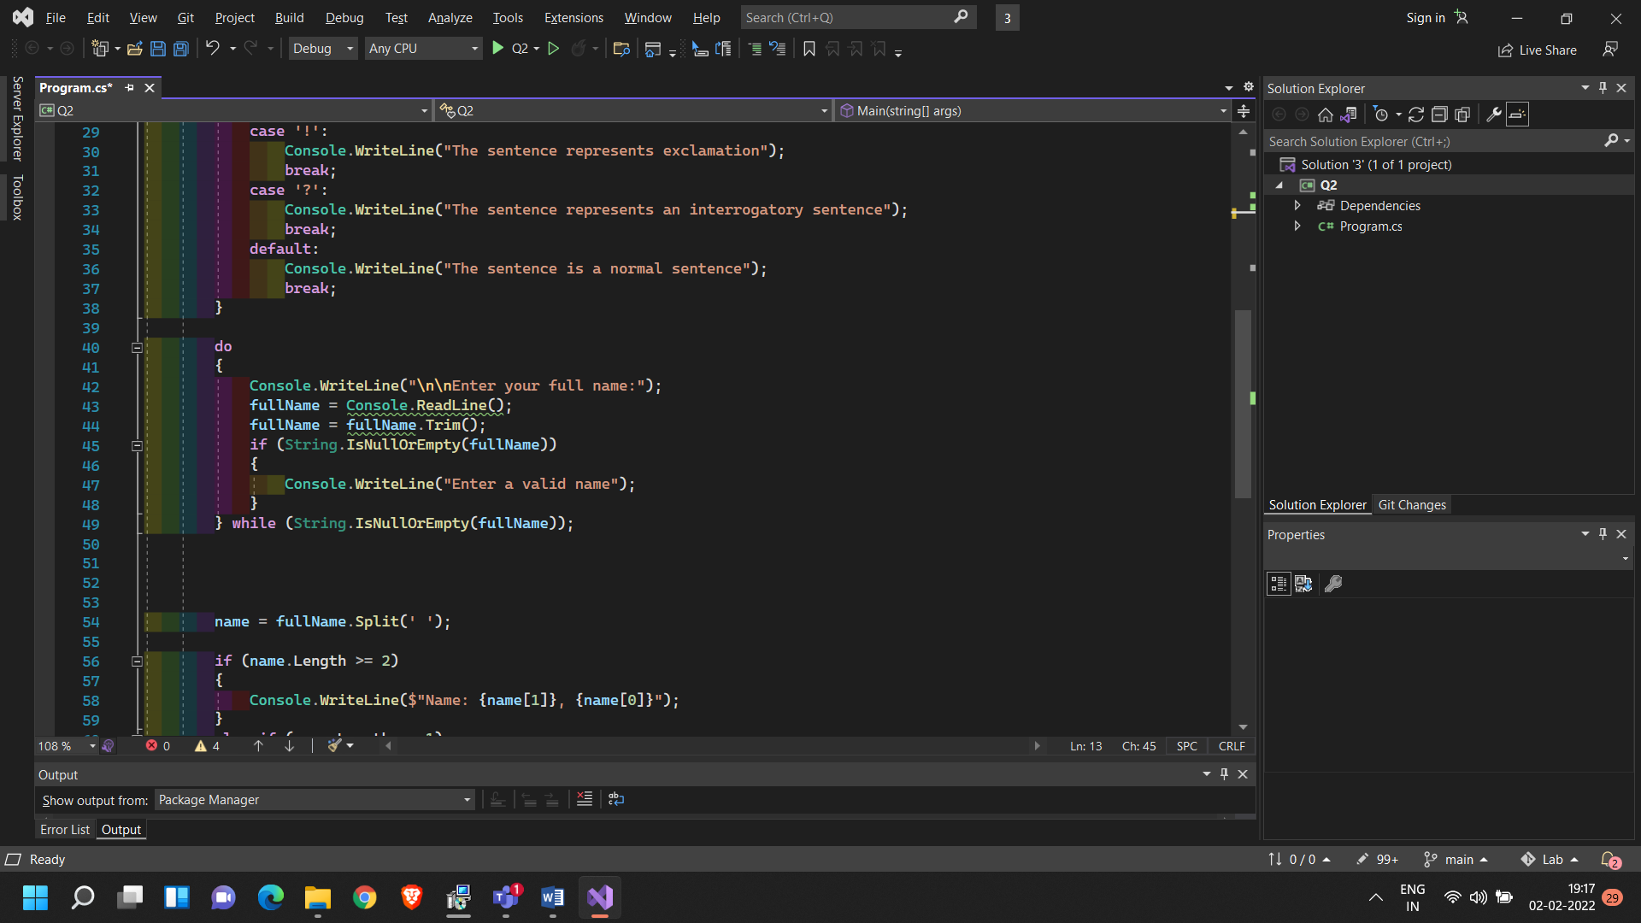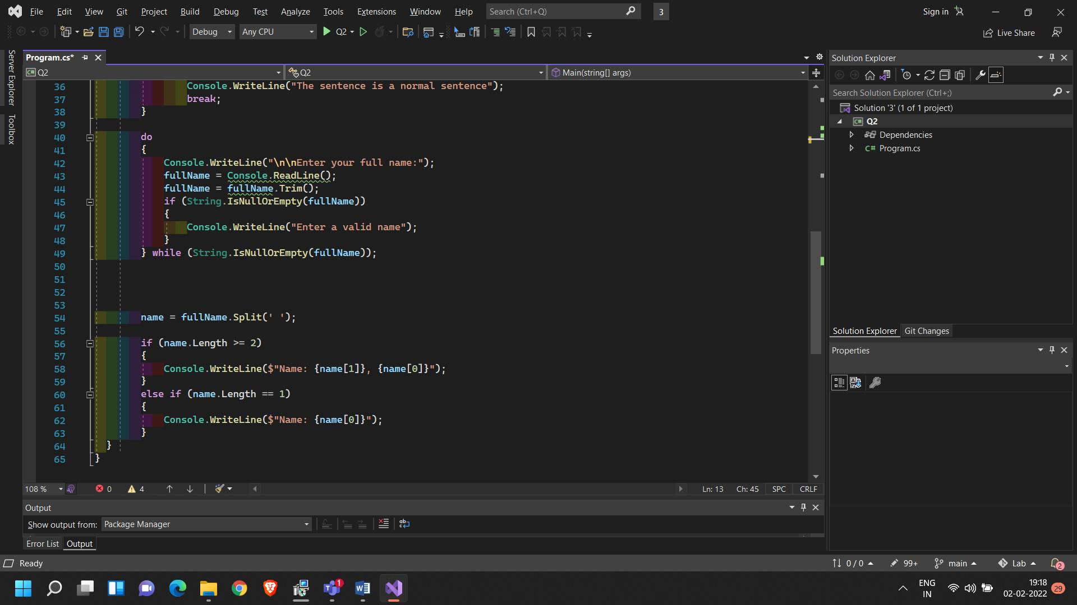

**Output:**

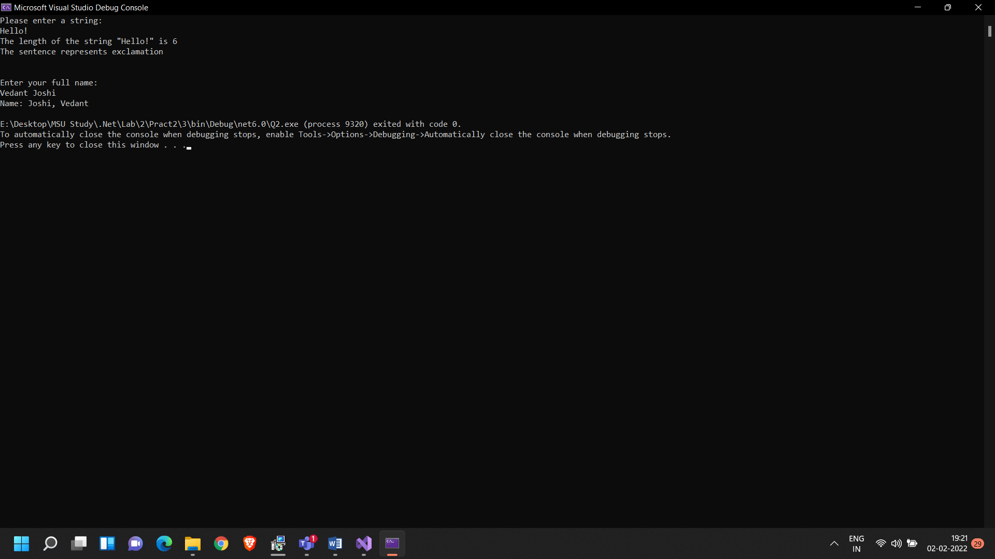

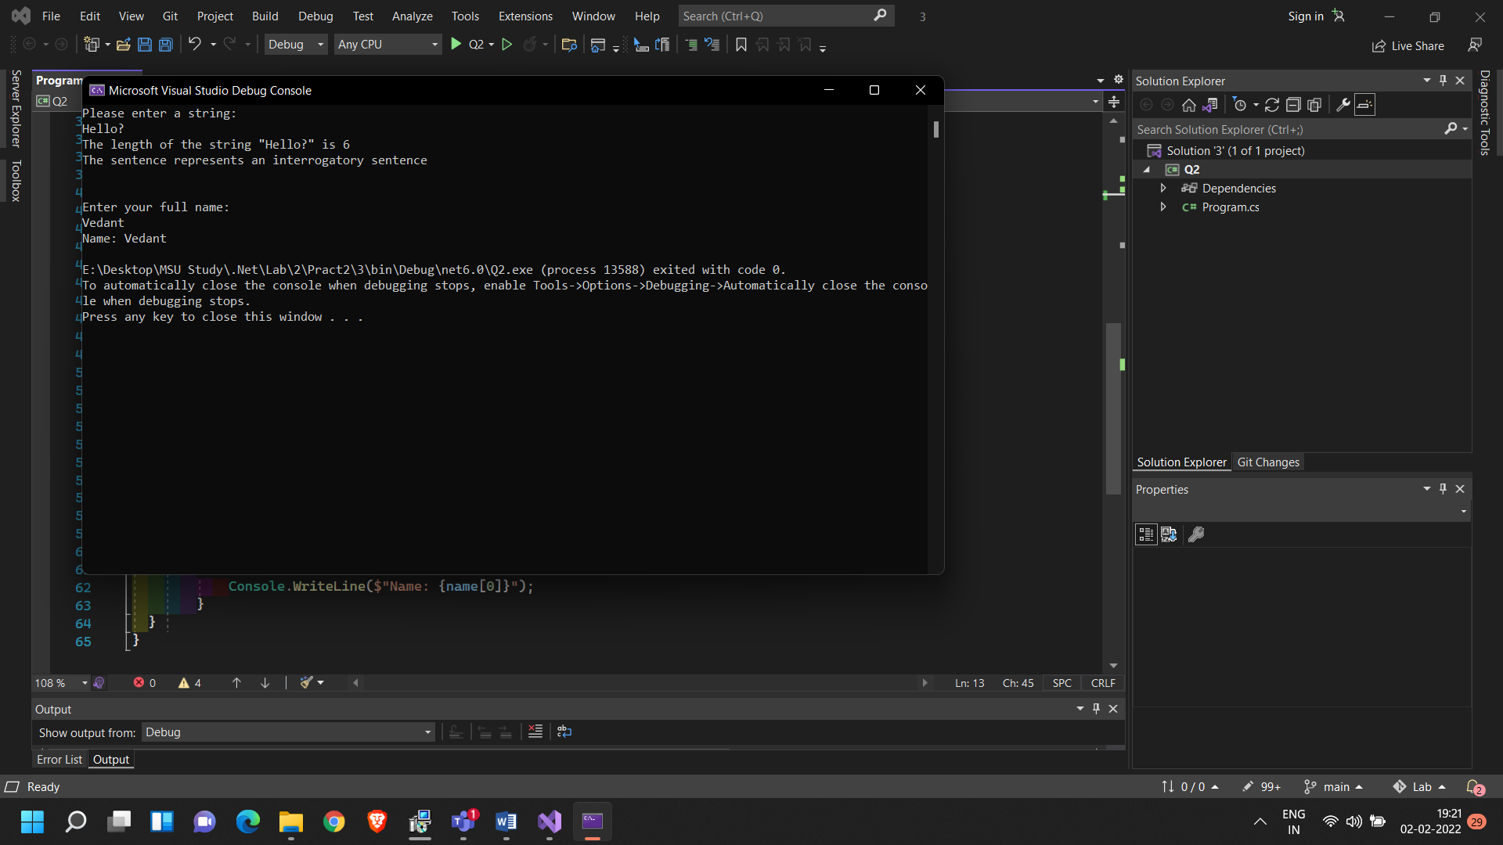

**Question 3: Enumeration Sample with bit flags (C# Microsoft.com)**

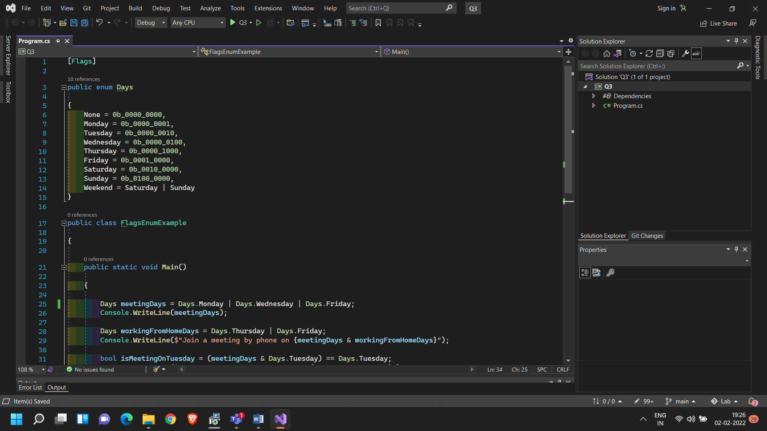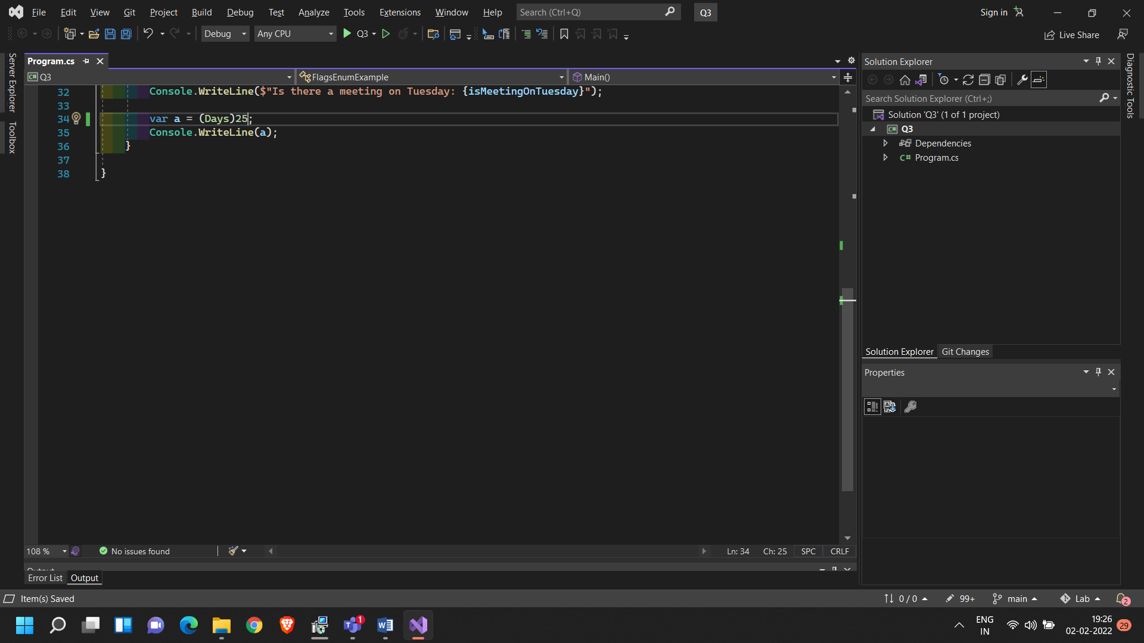

**Output:**

